Right Join

Definition
# Source: AI Source: Provided by: [Data Path: Persons Table -> ID Column: 1, Name_En Column: Motasem Essam] -> From: [Chatgpt (GPT‑5 Mini)] on [12/10/2025]
A Right Join or Right Outer Join is a data operation that combines two datasets while keeping all rows from the right table and adding the matching rows from the left table based on a common key. If there is no match in the left table, the result contains NULL or NaN values for the left-side columns.

Key Idea
# Source: AI Source: Provided by: [Data Path: Persons Table -> ID Column: 1, Name_En Column: Motasem Essam] -> From: [Chatgpt (GPT‑5 Mini)] on [12/10/2025]
A Right Join ensures that every record from the right dataset appears in the result, even if there is no corresponding record in the left dataset.

How It Works
# Source: AI Source: Provided by: [Data Path: Persons Table -> ID Column: 1, Name_En Column: Motasem Essam] -> From: [Chatgpt (GPT‑5 Mini)] on [12/10/2025]
- Select the right table (primary dataset).
- Select the left table to join with it.
- Match rows using a common key column.
- If a match exists → combine the rows.
- If no match exists → keep the right row and fill left columns with NULL/NaN.

Example
# Source: AI Source: Provided by: [Data Path: Persons Table -> ID Column: 1, Name_En Column: Motasem Essam] -> From: [Chatgpt (GPT‑5 Mini)] on [12/10/2025]
Dataset A – Customers (Left Table)
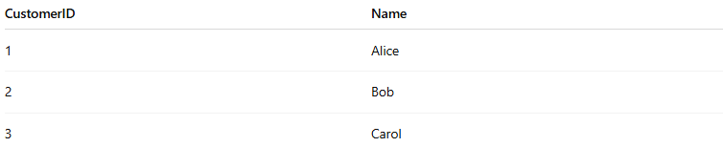
CustomerID | Name
1 | Alice
2 | Bob
3 | Carol
Dataset B – Orders (Right Table)
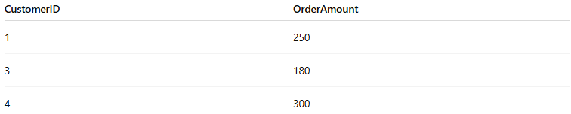
CustomerID | OrderAmount
1 | 250
3 | 180
4 | 300
Right Join on CustomerID
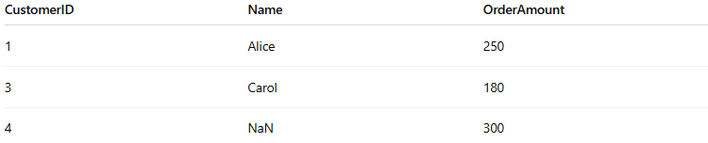
CustomerID | Name | OrderAmount
1 | Alice | 250
3 | Carol | 180
4 | NaN | 300
- Order 4 remains even though there is no matching customer in the left table.
- Missing values from the left table appear as NaN or NULL.

Applications
# Source: AI Source: Provided by: [Data Path: Persons Table -> ID Column: 1, Name_En Column: Motasem Essam] -> From: [Chatgpt (GPT‑5 Mini)] on [12/10/2025]
- Listing all orders, even if some orders do not have customer details
- Combining datasets when the right table is the primary data source
- Identifying missing or unmatched records

Advantages
# Source: AI Source: Provided by: [Data Path: Persons Table -> ID Column: 1, Name_En Column: Motasem Essam] -> From: [Chatgpt (GPT‑5 Mini)] on [12/10/2025]
- Keeps all records from the right dataset
- Helps identify missing relationships between tables
- Useful when the right table contains critical information

Disadvantages
# Source: AI Source: Provided by: [Data Path: Persons Table -> ID Column: 1, Name_En Column: Motasem Essam] -> From: [Chatgpt (GPT‑5 Mini)] on [12/10/2025]
- May produce NULL or NaN values for unmatched rows
- Less commonly used than Left Join in practice

